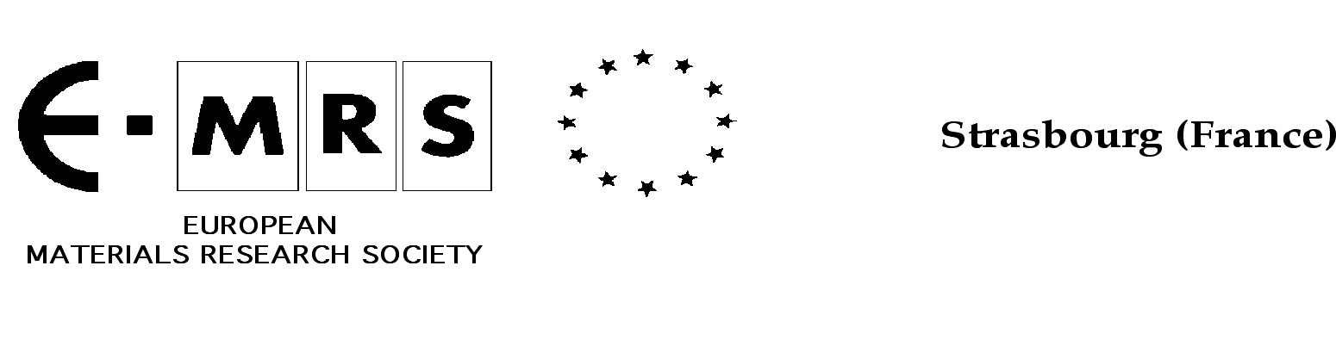

E-MRS SYMPOSIUM PROPOSAL
Application form

The E-MRS is now seeking for proposals for the Fall 2026 Conference & Exhibit to be held in Warsaw from September 14 to 17, 2026.
It is extremely important that many interesting topics are addressed, ranging from electronic nanomaterials to biomaterials for applications in electronics, energy saving and production and health sectors.
The first step in the overall process is to prepare a proposal and submit it to E-MRS Headquarters.
The symposium organizing committee should be preferentially an international one. A short CV of the proposed principal organiser and co-organisers should be included together with the 5 most relevant and recent publications in the last 2 years. This must be restricted to the single page included for each organiser.
Completed proposals applications should be sent by e-mail to
emrs@european-mrs.com
- Deadline for receipt of proposals: October 15th, 2025
- Acceptance: end of December 2025
Thank you for your participation.

The Organizing Committee

Proposal for : Spring 2026 Fall 2026 Both

1. Title (150 characters max.)

2. Suited journal(s) for publication of manuscripts

3. Symposium organizers

i) Main organizer :
First and last names
Affiliation
Address

Phone number
E-mail address

ii) Co-organizers : (maximum 3 - mandatory)
A  First and last names  Affiliation  Address  Phone number  E-mail address | B  First and last names  Affiliation  Address  Phone number  E-mail address
C
First and last names
Affiliation
Address

Phone number
E-mail address

CV of Principal organiser
Title Given Name: Family Name

CV of co-organiser A
Title Given Name: Family Name

CV of co-organiser B.
Title Given Name: Family Name

CV of co-organiser C.
Title Given Name: Family Name

4. Previously organized symposia

5. Description

i) Introduction (300 characters max.)

ii) Scope (2.000 characters max.) This must give sufficient detail to allow informed decision making – probably >1.200 characters

iii) Hot topics to be covered by the symposium (600 characters max.)

6. Other events focusing on the same or similar topics (250 characters max.)

7. Tentative list of invited speakers and, if possible, the title of the presentation (1.500 characters max.)

8. Tentative list of scientific committee members (1.000 characters max.)

9. Procedure for selecting the winners of the Young Researcher Awards (YRA) (150 characters max.)

10. Tentative Budget

(i) Tentative list of major sponsors (to be solicited) (150 characters max.)

(ii)

Anticipated Income;

Anticipated Expenditure:

Anticipated Balance + or -

11. Speaker(s) proposed for the plenary session (150 characters max.)

12. Additional points, remarks or comments

