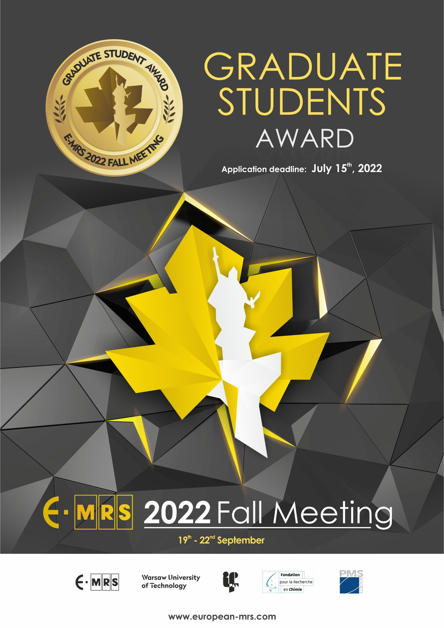

GRADUATE STUDENT AWARD

GENERAL INFORMATION

Eligibility
To be eligible for the E-MRS Graduate Student Award, the applicant must be registered as a graduate student with a PhD thesis research program closely related to the scope of one of the symposia held during the E-MRS 2022 Fall Meeting. The applicant is the main author or a co-author of a manuscript and must be entrusted with the (oral or poster) presentation of the paper. In addition, the applicant must pay the registration fee for students.

All finalists must attend the Graduate Student Award ceremony held at the beginning of the Reception on Wednesday evening September 21, 2022

Award Benefits
Each award will comprise a diploma and 350 EUR

Application

The applicant must submit BY EMAIL the following items (as a one single PDF file) to the E-MRS Warsaw Office in order to be considered for the Graduate Student Award competition:
- One completed application form
- One copy of the concerned abstract
- Description of work associated with the abstract to be considered
- Letter of support submitted by the thesis advisor

Procedure
The selection of winners will be achieved in two successive steps:
- First, a group of Graduate Student Award finalists will be identified on the basis of the award application. All finalists will be notified directly by the symposium organizer.
- Second, (only if necessary) all finalists will give an oral presentation of the paper for a special graduate student award session during the E-MRS 2022 Fall Meeting at a date and place indicated by the symposium organizer.

Deadline
All application material must be received by July 15, 2022

Att.: E-MRS Fall Meeting Secretariat: emrs@pw.edu.pl
Subject: Graduate Student Award – symposium … (mention the letter)

APPLICATIONS RECEIVED AFTER THE DEADLINE CANNOT BE CONSIDERED FOR AN E-MRS 2022 FALL MEETING GRADUATE STUDENT AWARD

APPLICATION FORM

NAME ……………………………………………………………………………………………………………….
FIRST NAME ……………………………………………………………………………………………………………….
INSTITUTE ……………………………………………………………………………………………………………….
ADDRESS ……………………………………………………………………………………………………………….
……………………………………………………………………………………………………………….
……………………………………………………………………………………………………………….
PHONE ……………………………………………………….
E-MAIL …………………………………………………….…

EDUCATION

- Graduate (current)

- Name and location of current graduate school, years of attendance:
…………………………………………………………………………………………………………………………………………………………………………………………………………………………………………………………………………
- What is your department?
…………………………………………………………………………………………………………………………………………………………………………………………………………………………………………………………………………
- What is your field of study?
…………………………………………………………………………………………………………………………………………………………………………………………………………………………………………………………………………
- What degree are you working toward?
…………………………………………………………………………………………………………………………………………………………………………………………………………………………………………………………………………
- When do you expect to receive this degree?
…………………………………………………………………………………………………………………………………………………………………………………………………………………………………………………………………………

- Previous graduate education

Name and location of school: ………………………………………………………………………………………………….………………………………..……………………………………………………………………………………………………………………………………
Department: …………………………………………………………………………………........................
Years of attendance: …………………………………………………………………………………………………
Major field of study: ………….……………………………………………………………………………………..
Degrees awarded and dates:
…………………..…………………………………………………………………………………………………………………………………………………………………………………………………………………………………………………………………………………………………………………………………………………………………………………………

- Undergraduate Education
Name and location of school: …………………………………………………………………………………………………...………………………………
Years of attendance: …………………………………………………………………………………………………
Major Field of study: …………………………………………………………………………………………………
Degrees awarded and dates: …………………………………………………………………………………………………..……………………………………………………………………………………………………………………………………………………………………

- Other training (list any other special training you have received)
……………………………………………………………………………………………………………………………………
……………………………………………………………………………………………………………………………………
……………………………………………………………………………………………………………………………………

SYMPOSIUM PARTICIPATION

Please mark with an “X” the symposium (only one symposium) corresponding to your manuscript submission. Please join a copy of your abstract.

FUNCTIONAL MATERIALS
A Materials, components and characterization of energy harvesters for self-powered electronics
C From predictive modelling to machine learning as versatile tools for materials design
E Sustainable materials for chemical and electrochemical energy storage
R Integration of advanced materials on silicon: from classical to neuromorphic and quantum applications
S Phase transitions and properties of ferroics in the form of single crystals, ceramics and thin films II

WIDE-BAND-GAP SEMICONDUCTORS
F Ultra wide-band-gap semiconductors for energy and electronics (UWBG2E)
G New frontiers in wide-band-gap semiconductors and heterostructures for electronics, optoelectronics and sensing

NANOMATERIALS
H Innovative and advanced epitaxy
I Group-IV semiconductor materials for nanoelectronics and cryogenic electronics
J Quantum semiconductors symposium
K Materials- nanoelectronics and nanophotonics
L Doping at the nanoscale: new challenges and advanced applications
M Defect-induced effects in nanomaterials

MATERIALS FOR A SUSTAINABLE TRANSITION
N Modelling and characterization of novel functional materials for green energy, sensing, and catalysis applications
O Circular materials and resource chemistry
P Breakthrough zero-emissions energy storage and conversion technologies for carbon-neutrality
Q Advanced catalytic materials for (photo)electrochem. energy conversion III

SUPPORTING INFORMATION

DESCRIPTION OF WORK TO BE CONSIDERED FOR A STUDENT AWARD

Describe briefly (not more than two pages) the work you wish to submit for a graduate student award. Include a short statement of background for your work, a description of its aim and scope, any unique features of your approach, your specific contributions, and any significant results.

Date Applicant’s signature Thesis Advisor’s signature

Please send this application duly filled out, as one pdf file together with the letter of support, the description of the work and abstract of your paper before July 15, 2022, even if the acceptance letter of your abstract has not reached you before the deadline for application, to:

E-MRS 2022 FALL MEETING
Att. Graduate Student Award
Warsaw University of Technology
Faculty of Materials Science and Engineering
141 Woloska Street
02-507 Warsaw, Poland

Email: emrs@pw.edu.pl

LETTER OF SUPPORT

GRADUATE STUDENT AWARD

TO BE FILLED IN BY APPLICANT

NAME ……………………………………………………………………………………………………………….
FIRST NAME ……………………………………………………………………………………………………………….
INSTITUTE ……………………………………………………………………………………………………………….
ADDRESS ……………………………………………………………………………………………………………….
……………………………………………………………………………………………………………….
……………………………………………………………………………………………………………….
PHONE ……………………………………………………….
FAX …………………………………………………….…
E-MAIL …………………………………………………….…

THESIS ADVISOR …………………………………………………………………………………………………….
INSTITUTE ……………………………………………………………………………………………………………….
ADDRESS ……………………………………………………………………………………………………………….
……………………………………………………………………………………………………………….
……………………………………………………………………………………………………………….
PHONE ……………………………………………………….
E-MAIL …………………………………………………….…

INSTRUCTION TO THESIS ADVISOR

On a separate sheet (maximum one page), please comment on the performance of the above-named student in the conduct of his/her research project and his/her promise for future substantial achievement in materials research. Note especially the applicant’s original contribution to the research project and compare with other students.

Using a scale of 0 to 4 (most favourable) points, supplement your written comments with numerical rankings in the three categories listed below.

… Quality and thoroughness of research conducted by applicant
… Originality of applicant’s contribution
… Independence of applicant’s research from advisor’s guidance.

Date Thesis Advisor’s signature

