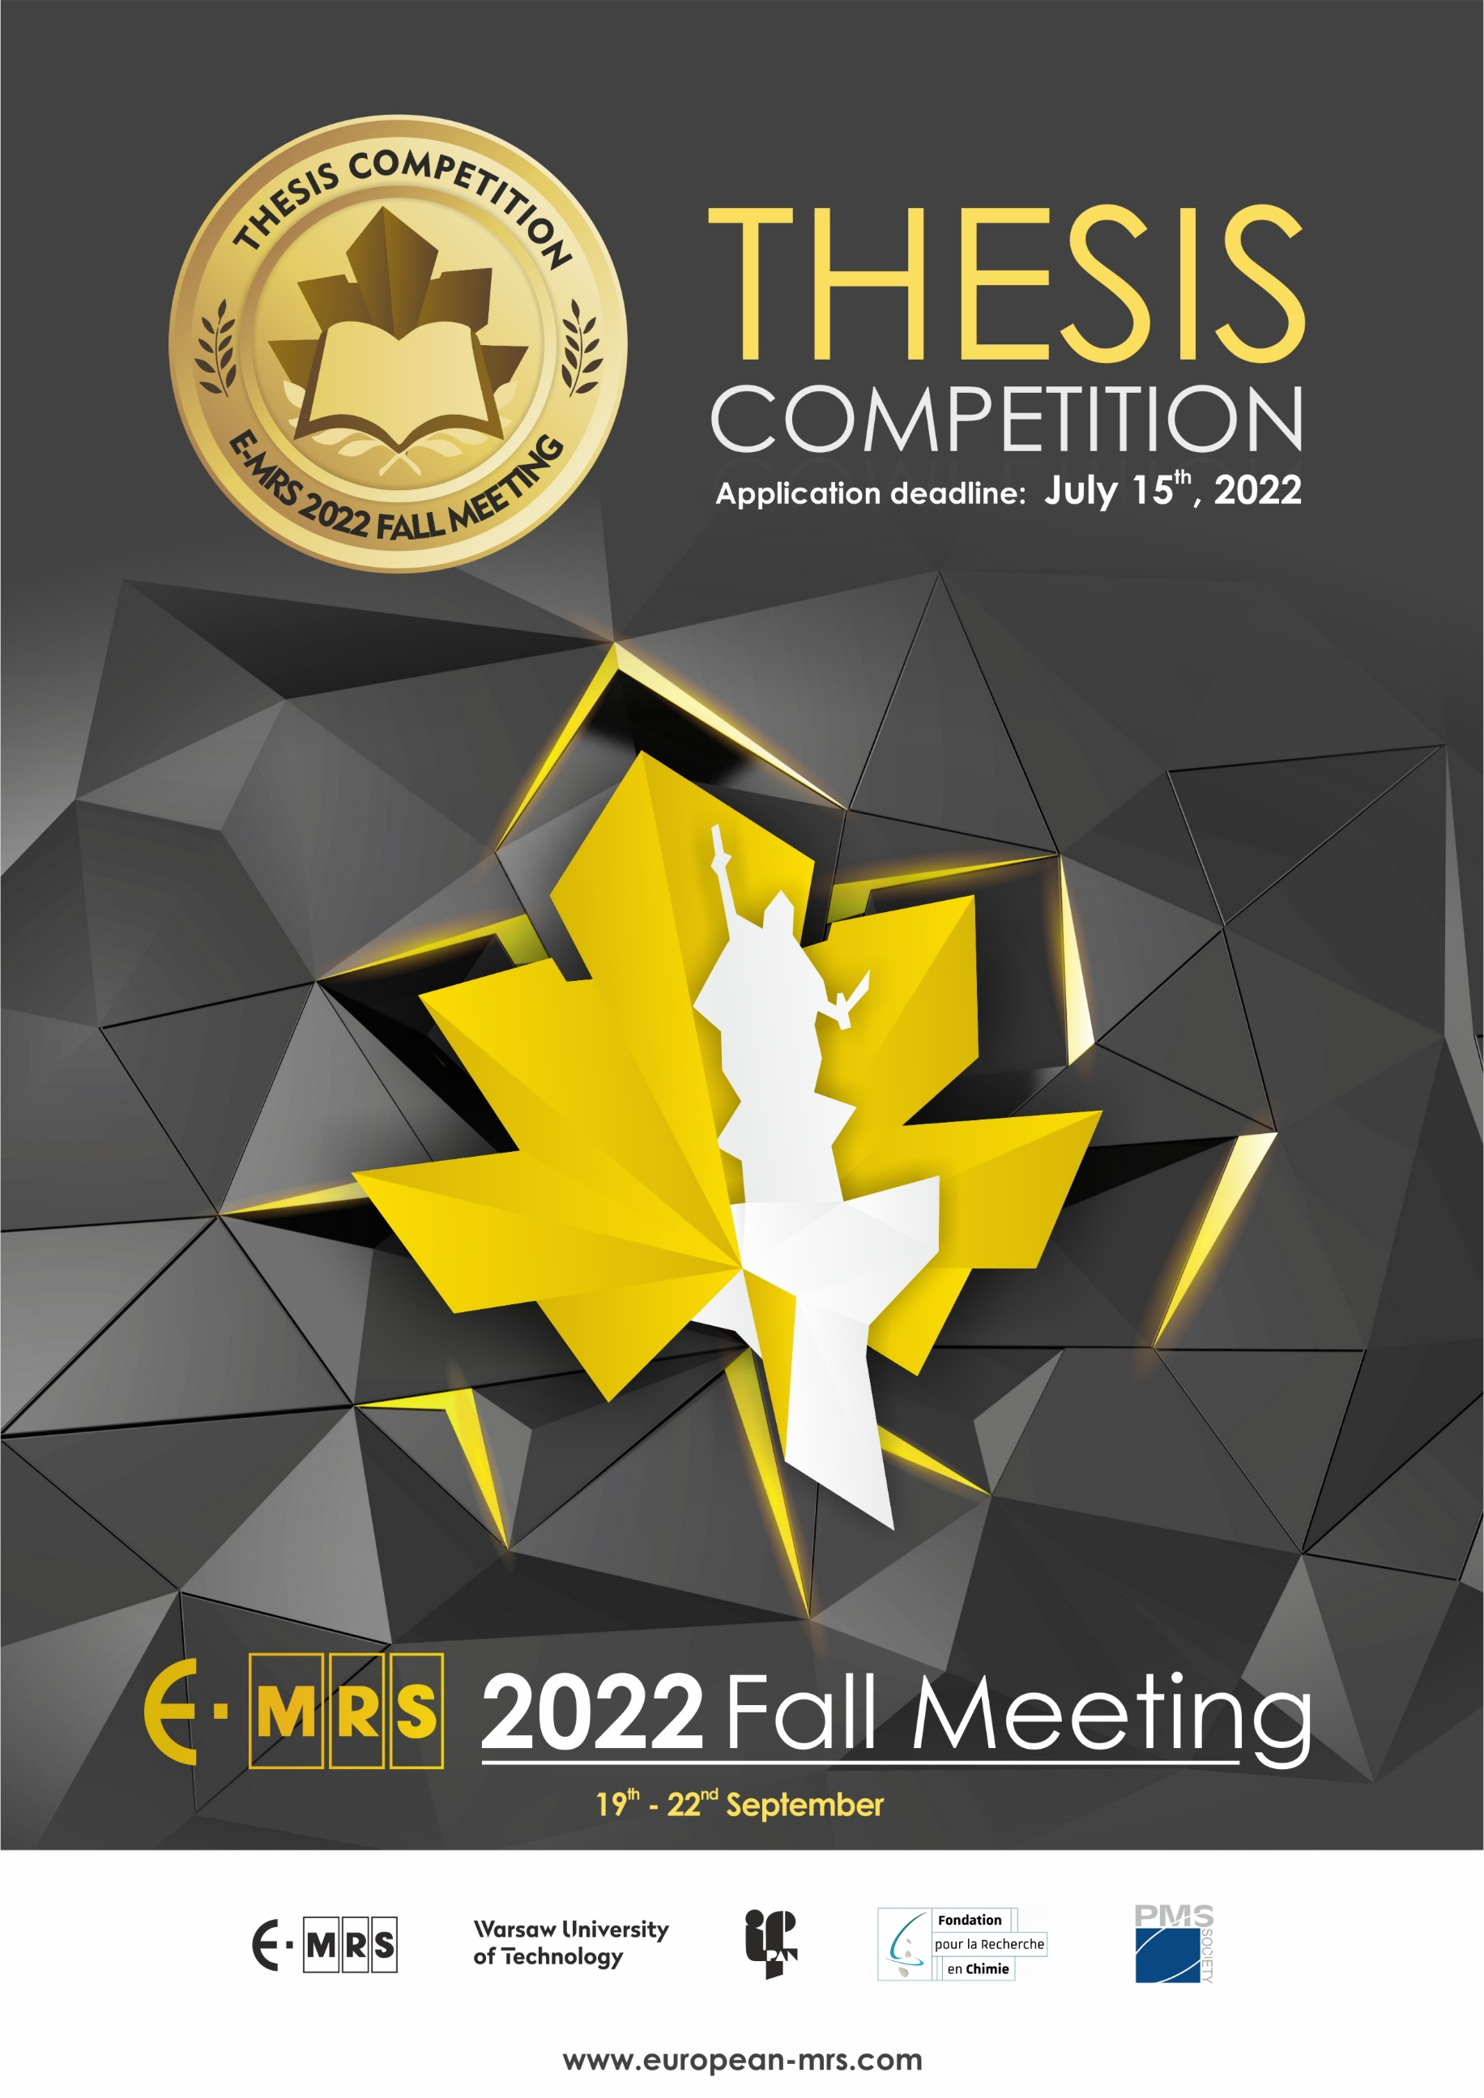

THESIS COMPETITION

Deadline for registration
Registration form must be received by July 15th, 2022

Att.: E-MRS Fall Meeting Secretariat: emrs@pw.edu.pl
Subject: Thesis competition – applicant’s name

REGISTRATION FORM

NAME ……………………………………………………………………………………………………………….
FIRST NAME ……………………………………………………………………………………………………………….
INSTITUTE ……………………………………………………………………………………………………………….
DEPARTMENT ………………………………………………………………………………........................
COUNTRY ……………………………………………………………………………………………………………….
E-MAIL …………………………………………………….…

Title of Research Project
………………………………………………………………………………………………………………………………….
Which symposium are you attending at E-MRS? ………………………………………………………………………………………………………………………………….
Which year of your doctoral studies are you currently in? ………………………………………………………………………………………………………………………………….

Date Signature

