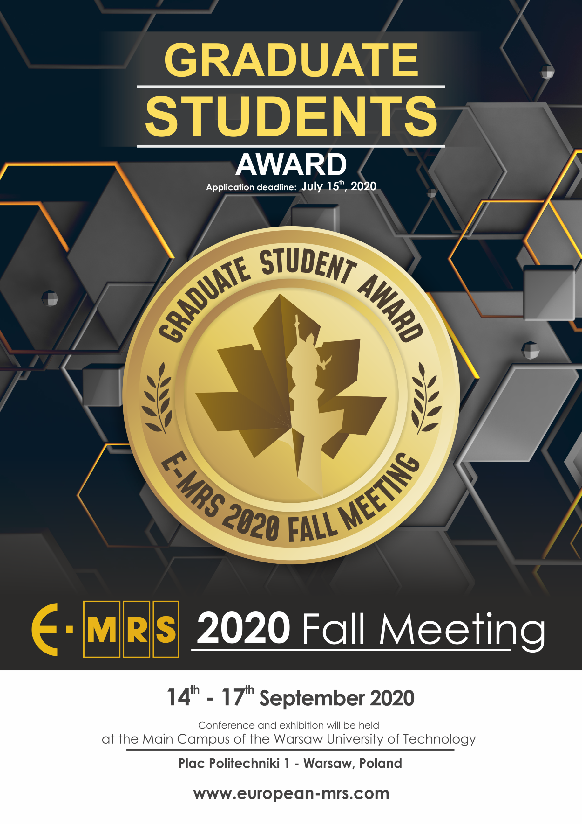

GRADUATE STUDENT AWARD

GENERAL INFORMATION

Eligibility
To be eligible for the E-MRS Graduate Student Award, the applicant must be registered as a graduate student with a PhD thesis research program closely related to the scope of one of the symposia held during the E-MRS 2020 Fall Meeting. The applicant is the main author or a co-author of a manuscript and must be entrusted with the (oral or poster) presentation of the paper. In addition, the applicant must pay the registration fee for students.

All finalists must attend the Graduate Student Award ceremony held at the beginning of the Reception on Wednesday evening September 16, 2020

Award Benefits
Each award will comprise a diploma and 350 EUR

Application

The applicant must submit BY EMAIL the following items (as a one single PDF file) to the E-MRS Warsaw Office in order to be considered for the Graduate Student Award competition:
- One completed application form
- One copy of the concerned abstract
- Description of work associated with the abstract to be considered
- Letter of support submitted by the thesis advisor

Procedure
The selection of winners will be achieved in two successive steps:
- First, a group of Graduate Student Award finalists will be identified on the basis of the award application. All finalists will be notified directly by the symposium organizer.
- Second, (if necessary) all finalists will give an oral presentation of the paper for a special graduate student award session during the E-MRS 2020 Fall Meeting at a date and place indicated by the symposium organizer.

Deadline
All application material must be received by July 15, 2020

Att.: E-MRS Fall Meeting Secretariat: emrs@pw.edu.pl
Subject: Graduate Student Award – symposium … (mention the letter)

APPLICATIONS RECEIVED AFTER THE DEADLINE CANNOT BE CONSIDERED FOR AN E-MRS 2020 FALL MEETING GRADUATE STUDENT AWARD

APPLICATION FORM

NAME ……………………………………………………………………………………………………………….
FIRST NAME ……………………………………………………………………………………………………………….
INSTITUTE ……………………………………………………………………………………………………………….
ADDRESS ……………………………………………………………………………………………………………….
……………………………………………………………………………………………………………….
……………………………………………………………………………………………………………….
PHONE ……………………………………………………….
E-MAIL …………………………………………………….…

EDUCATION

- Graduate (current)

- Name and location of current graduate school, years of attendance:
…………………………………………………………………………………………………………………………………………………………………………………………………………………………………………………………………………
- What is your department?
…………………………………………………………………………………………………………………………………………………………………………………………………………………………………………………………………………
- What is your field of study?
…………………………………………………………………………………………………………………………………………………………………………………………………………………………………………………………………………
- What degree are you working toward?
…………………………………………………………………………………………………………………………………………………………………………………………………………………………………………………………………………
- When do you expect to receive this degree?
…………………………………………………………………………………………………………………………………………………………………………………………………………………………………………………………………………

- Previous graduate education

Name and location of school: ………………………………………………………………………………………………….………………………………..……………………………………………………………………………………………………………………………………
Department: …………………………………………………………………………………........................
Years of attendance: …………………………………………………………………………………………………
Major field of study: ………….……………………………………………………………………………………..
Degrees awarded and dates:
…………………..…………………………………………………………………………………………………………………………………………………………………………………………………………………………………………………………………………………………………………………………………………………………………………………………

- Undergraduate Education
Name and location of school: …………………………………………………………………………………………………...………………………………
Years of attendance: …………………………………………………………………………………………………
Major Field of study: …………………………………………………………………………………………………
Degrees awarded and dates: …………………………………………………………………………………………………..……………………………………………………………………………………………………………………………………………………………………

- Other training (list any other special training you have received)
……………………………………………………………………………………………………………………………………
……………………………………………………………………………………………………………………………………
……………………………………………………………………………………………………………………………………
……………………………………………………………………………………………………………………………………

SYMPOSIUM PARTICIPATION

Please mark with an “X” the symposium (only one symposium) corresponding to your manuscript submission. Please join a copy of your abstract.

MATERIALS FOR ENERGY
- A Materials for energy applications: hydrogen storage/production, solar cells, super capacitors, thermoelectric & carbon-based materials
- B Battery and energy storage devices: from materials to eco-design
- C Advanced catalytic materials for (photo)electrochemical energy conversion II
- D Materials for chemical and electrochemical energy storage
- E Nuclear materials

MODELLING AND CHARACTERIZATION
- F Computer-aided materials modelling: fundamental and applied insights merging physics and chemistry viewpoints at the atomic-scale
- G Modern computational methods and their applications in materials science: Synergy of theory and experiment
- H European Nanoanalysis Symposium (8th Dresden Nanoanalysis Symposium “on tour”)

FUNCTIONAL MATERIALS
- I Materials and technological solutions preventing biofilms and antimicrobial resistance
- J Peptide self-assembly in materials science
- K Integration of advanced materials on silicon: from classical to neuromorphic and quantum applications
- L Emergent functional materials with respect to extreme conditions
- M Interface phenomena in emerging electronic and energy technologies
- N New frontiers in topological matters

OXIDES, FERROELECTRICS
- O Wide band gap (WBG) materials: theory, growth, characterization, and applications
- P Phase transitions and properties of ferroics in the form of single crystals, ceramics and thin films – II. 2020
- Q (Hf,Zr)O2-based ferroelectrics: from fundamentals to applications

FUNDAMENTALS
- R Nanomaterials- electronics & -photonics
- S Design and Manufacturing of 3D optical nanostructures and nanophotonics
- T Organized nanostructures and nano-objects: fabrication, characterization and applications V
- U Advances in nanoparticles: synthesis, characterisation, theoretical modelling, and applications
- V Polytypism in semiconductors

MANUFACTURING AND TECHNOLOGY
- W 3D printing and additive manufacturing for the industry of the future (2nd edition)
- X Crystal Growth of Organic Materials

SUPPORTING INFORMATION

A letter of support (form attached) for this award must be submitted by your thesis advisor. Alert your advisor to the deadline of July 15, 2020 by which this letter must be received by E-MRS.

DESCRIPTION OF WORK TO BE CONSIDERED FOR A STUDENT AWARD

Describe briefly (not more than two pages) the work you wish to submit for a graduate student award. Include a short statement of background for your work, a description of its aim and scope, any unique features of your approach, your specific contributions, and any significant results.

Date Applicant’s signature Advisor’s signature

Please send this application duly filled out, together with the letter of support, the description of the work and abstract of your paper before July 15, 2020, even if the acceptance letter of your abstract has not reached you before the deadline for application, to:

E-MRS 2020 FALL MEETING

Subject: Graduate Student Award – symposium … (mention the letter)

Email: emrs@pw.edu.pl

LETTER OF SUPPORT

GRADUATE STUDENT AWARD

TO BE FILLED IN BY APPLICANT

NAME ……………………………………………………………………………………………………………….
FIRST NAME ……………………………………………………………………………………………………………….
INSTITUTE ……………………………………………………………………………………………………………….
ADDRESS ……………………………………………………………………………………………………………….
……………………………………………………………………………………………………………….
……………………………………………………………………………………………………………….
PHONE ……………………………………………………….
FAX …………………………………………………….…
E-MAIL …………………………………………………….…

THESIS ADVISOR …………………………………………………………………………………………………….
INSTITUTE ……………………………………………………………………………………………………………….
ADDRESS ……………………………………………………………………………………………………………….
……………………………………………………………………………………………………………….
……………………………………………………………………………………………………………….
PHONE ……………………………………………………….
E-MAIL …………………………………………………….…

INSTRUCTION TO THESIS ADVISOR

On a separate sheet (maximum one page), please comment on the performance of the above-named student in the conduct of his/her research project and his/her promise for future substantial achievement in materials research. Note especially the applicant’s original contribution to the research project and compare with other students.

Using a scale of 0 to 4 (most favourable) points, supplement your written comments with numerical rankings in the three categories listed below.

… Quality and thoroughness of research conducted by applicant
… Originality of applicant’s contribution
… Independence of applicant’s research from advisor’s guidance.

Date Advisor’s signature

