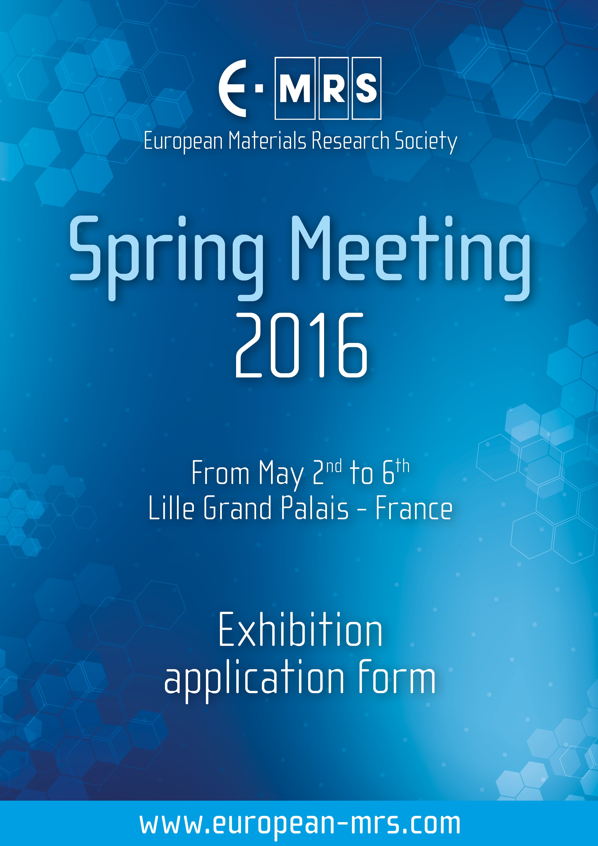
Reach.Out! Competition


Reach Out! Competition
GENERAL INFORMATION

Reach Out! is a science communication competition that aims to engage the members of the European Materials Science community in public outreach activities. E-MRS, as a partner of the EU project STIMULATE (“Stimulating the public attitude towards advanced materials”), seeks to recognize members of the Materials Science community (students, scientists, engineers, researchers etc) who have designed, organized and implemented a public outreach activity in the EU between the 1st of May 2015 and the 31st of March 2016.

This outreach activity must be related to Advanced Materials and its main aim must have been to uncover to the non-specialists one or more of the following aspects of work within this field: the applications, the benefit for the society and the economy, the people behind the scenes, the complexity of the work done, even possible controversies etc.

Eligibility

Entrants must be individuals of 18 years old or more, and members of the European Materials Science community, i.e. currently studying or having studied a relevant subject at University (from undergraduate to doctoral level), or working in the science, technology or engineering of Advanced Materials. Their project may be a result of personal or team work.

Procedure

The selection of the winners will be achieved by a judging committee, consisting of distinguished researchers and science communicators. The finalists will be selected based on the following criteria:

- Impact
The number of people that the project has reached, its aims and how they were met, its social or economic aspects, the stakeholders’ gain and feedback, etc.

- Accuracy
The project must be scientifically correct, and must also be relevant to the field of Advanced Materials.

- Innovation and Creativity
The originality, the creativity and the innovation involved in the project will be also evaluated.

Project ideas may include (but not be restricted to) tools like:
- Popular science articles (printed or digital)
- Blogging
- Storytelling
- Experimental exhibitions and science shows

- Theatre or stand-up comedy shows
- Videos or mini documentaries
- Café scientific talks or presentations
- Science and Art blending
- Games (mental or physical skills games, digital or real-life ones)
- Musical composition or song writing

There is no limitation as far as the target audience is concerned, but both the project’s aims and target group must be explicitly mentioned.

All finalists must attend the Reach.Out! Award ceremony held during the plenary session on Wednesday afternoon May 4, 2016.

Award Benefits

According to the jury’s ranking, three prizes will be awarded, accompanied with a diploma:
1. First Place: 1000 EUR cash prize
2. Second Place: 700 EUR cash prize
3. Third Place: 500 EUR cash prize

Application

The applicant must submit BY EMAIL to the E-MRS HQ the following items in order to be considered for the Reach Out! Competition:

- One completed application form.

- Any other material supporting the project (brief summary, detailed actions, including the aims, the measurables, the impact, comments from stakeholders, etc. and any online material that backs up the project e.g. website, Facebook page, YouTube channel etc, and up to 10 photos and 2 videos).

We encourage participation from every part of the EU and activities in any EU language, but, for evaluation purposes, please make sure that the above items, including important parts of the supporting material (videos, web pages, etc), are submitted in the English language.

Deadline

All application materials must be received by April 15, 2016
at EMRS HQ: nathalie.geyer@european-mrs.com

The finalists will be announced at the Reach Out! Award Ceremony held during the plenary session on 4 May 2016.

APPLICATIONS RECEIVED AFTER THE DEADLINE CANNOT BE CONSIDERED FOR A REACH OUT! COMPETITION AWARD
APPLICATION FORM
CONTACT PERSON’S DETAILS

NAME …………………………………………………………………………………………………………….
FIRST NAME …………………………………………………………………………………………………………….
AFFILIATION …………………………………………………………………………………………………………...
ADDRESS …………………………………………………………………………………………………………….
…………………………………………………………………………………………………………….
PHONE ……………………………………………………….
E-MAIL ……………………………………………………….

SHORT DESCRIPTION OF THE PARTICIPANT(S) (MAX. 150 WORDS)

Write a short CV (individual participation) or a short description of the team members (team participation), stating your scientific background, field of study, etc.
……………………………………………………………………………………………………………………………………
……………………………………………………………………………………………………………………………………
……………………………………………………………………………………………………………………………………
……………………………………………………………………………………………………………………………………
……………………………………………………………………………………………………………………………………
……………………………………………………………………………………………………………………………………
……………………………………………………………………………………………………………………………………
……………………………………………………………………………………………………………………………………
……………………………………………………………………………………………………………………………………
……………………………………………………………………………………………………………………………………
……………………………………………………………………………………………………………………………………

PREVIOUS EXPERIENCE

Have you participated in another outreach activity in the past? If yes, which one?
……………………………………………………………………………………………………………………………………
……………………………………………………………………………………………………………………………………
……………………………………………………………………………………………………………………………………
……………………………………………………………………………………………………………………………………
……………………………………………………………………………………………………………………………………

FOLLOW UP

Would you be interested in participating in more science communication activities in European level in collaboration with E-MRS?

€ YES € NO

SUPPORTING INFORMATION

BRIEF SUMMARY OF THE PROJECT (MAX. 100 WORDS)

Describe briefly the project you wish to submit for the Reach Out! Competition award.

……………………………………………………………………………………………………………………………………
……………………………………………………………………………………………………………………………………
……………………………………………………………………………………………………………………………………
……………………………………………………………………………………………………………………………………
……………………………………………………………………………………………………………………………………
……………………………………………………………………………………………………………………………………
……………………………………………………………………………………………………………………………………
……………………………………………………………………………………………………………………………………
……………………………………………………………………………………………………………………………………
……………………………………………………………………………………………………………………………………

DESCRIPTION OF THE ACTION (MAX. 500 WORDS)

Describe in a more detailed way the action, including the aims, the measurables, the impact, comments from stakeholders, etc. and any online material that backs up the project (website, Facebook page, YouTube channel etc)

……………………………………………………………………………………………………………………………………
……………………………………………………………………………………………………………………………………
……………………………………………………………………………………………………………………………………
……………………………………………………………………………………………………………………………………
……………………………………………………………………………………………………………………………………
…………………………………………………………………………………………………………………………………………………………………………………………………………………………………………………………………………
……………………………………………………………………………………………………………………………………
……………………………………………………………………………………………………………………………………
……………………………………………………………………………………………………………………………………
……………………………………………………………………………………………………………………………………
……………………………………………………………………………………………………………………………………
……………………………………………………………………………………………………………………………………
……………………………………………………………………………………………………………………………………
……………………………………………………………………………………………………………………………………
……………………………………………………………………………………………………………………………………
……………………………………………………………………………………………………………………………………
……………………………………………………………………………………………………………………………………
……………………………………………………………………………………………………………………………………
……………………………………………………………………………………………………………………………………
……………………………………………………………………………………………………………………………………
……………………………………………………………………………………………………………………………………
……………………………………………………………………………………………………………………………………
……………………………………………………………………………………………………………………………………
……………………………………………………………………………………………………………………………………
……………………………………………………………………………………………………………………………………
……………………………………………………………………………………………………………………………………
……………………………………………………………………………………………………………………………………
……………………………………………………………………………………………………………………………………
……………………………………………………………………………………………………………………………………
……………………………………………………………………………………………………………………………………
……………………………………………………………………………………………………………………………………
……………………………………………………………………………………………………………………………………
……………………………………………………………………………………………………………………………………
……………………………………………………………………………………………………………………………………
……………………………………………………………………………………………………………………………………
……………………………………………………………………………………………………………………………………
……………………………………………………………………………………………………………………………………
……………………………………………………………………………………………………………………………………
……………………………………………………………………………………………………………………………………
……………………………………………………………………………………………………………………………………

YOU CAN ADD UP TO 10 PHOTOS AND 2 VIDEOS, SUPPORTING THE PROJECT

Date

OTHER COMMENTS

You may add here any other general comments that you would like to note down for the organizers’ information.
……………………………………………………………………………………………………………………………………
……………………………………………………………………………………………………………………………………
……………………………………………………………………………………………………………………………………
……………………………………………………………………………………………………………………………………
……………………………………………………………………………………………………………………………………
……………………………………………………………………………………………………………………………………

Please send this application duly filled out, with all required documents before April 15th, 2016 to:

nathalie.geyer@european-mrs.com

Mentioning
Reach Out! Competition Award 2016

