
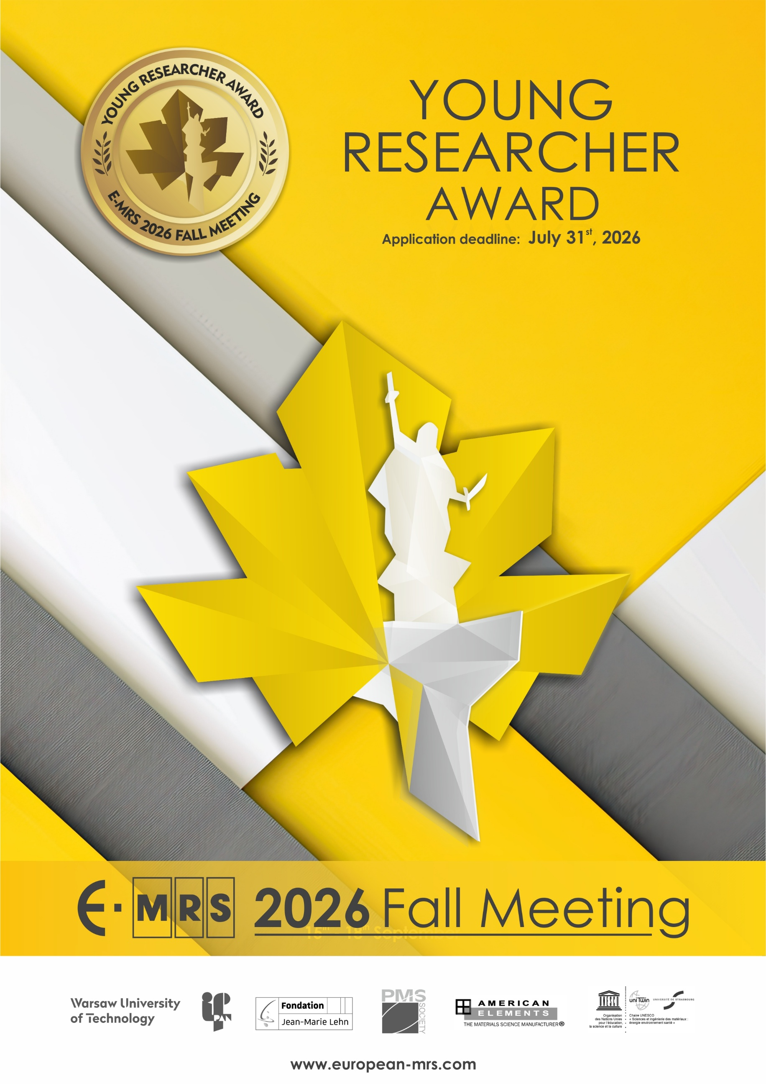

YOUNG RESEARCHER AWARD

GENERAL INFORMATION

Eligibility
To be eligible for an E-MRS Young Researcher Award at the E-MRS 2026 Fall Meeting, the applicant must be registered as a student undertaking a PhD research program on a topic within the scope of a symposium held during the E-MRS 2026 Fall Meeting.
The applicant must be the main, or a coauthor, of a manuscript and must be responsible for the oral or poster presentation of the paper to be delivered at the conference. In addition, the appropriate registration fee for participation at the conference must be paid by, or on behalf of the applicant prior to the conference.

All finalists must attend the Young Researcher Award ceremony held at the beginning of the Reception on Wednesday evening September 16, 2026

Award Benefits
Each award winner will receive 450 Euro and a personalized Award Certificate.

Application
The applicant must submit the following items attached to an email as a single pdf to the E-MRS Fall Meeting secretariat emrs@pw.edu.pl in order to be considered for the Young Researcher Award competition:
• The completed application form
• One copy of the abstract submitted to the conference
• Description of work associated with the abstract to be considered
• Letter of support submitted by the candidate’s PhD Supervisor.

Procedure
The award winners will be selected by the following two stage process:
• A short list of candidates will be selected on the basis of the application form and recommendation as decided by the symposium organizers.
• Upon review of applications, the selected Young Researcher Award finalists will present their research, based on their abstract as submitted and accepted for the E-MRS 2024 Fall Meeting.

Presentation of research may occur in either a virtual or in-person format to be determined by E-MRS at a later date. Selected finalists must be available to participate on the designated date in order to maintain eligibility to receive a Young Researcher Award.

Deadline
Applications must be submitted to E-MRS Fall Meeting Secretariat emrs@pw.edu.pl, on or before July 31, 2026. Any application received after the deadline will not be considered.

Note: Any canvassing on behalf on a candidate by any person will automatically disqualify the candidate.

APPLICATION FORM

NAME ……………………………………………………………………………………………………………….
FIRST NAME ……………………………………………………………………………………………………………….
INSTITUTE ……………………………………………………………………………………………………………….
ADDRESS ……………………………………………………………………………………………………………….
……………………………………………………………………………………………………………….
……………………………………………………………………………………………………………….
PHONE ……………………………………………………….
E-MAIL …………………………………………………….…

EDUCATION

- Graduate (current)

- Name and location of current graduate school, years of attendance:
……………………………………………………………………………………………………………………………………
- What is your department?
……………………………………………………………………………………………………………………………………
- What is your field of study?
……………………………………………………………………………………………………………………………………
- What degree are you working toward?
……………………………………………………………………………………………………………………………………
- When do you expect to receive this degree?
…………………………………………………………………………………………………………………………………………………………………………………………………………………………………………………………………………

- Previous graduate education

Name and location of school: ………………………………………………………………………………………………….………………………………..
Department: …………………………………………………………………………………........................
Years of attendance: …………………………………………………………………………………………………
Major field of study: ………….……………………………………………………………………………………..
Degrees awarded and dates:
…………………..……………………………………………………………………………………………………………………………………………………………………………………………………………………………………………………

- Undergraduate Education
Name and location of school: …………………………………………………………………………………………………...………………………………
Years of attendance: …………………………………………………………………………………………………
Major Field of study: …………………………………………………………………………………………………
Degrees awarded and dates: …………………………………………………………………………………………………..……………………………………………………………………………………………………………………………………………………………………

- Other training (list any other special training you have received)
……………………………………………………………………………………………………………………………………
……………………………………………………………………………………………………………………………………
SYMPOSIUM PARTICIPATION

Please mark with an “X” the symposium (only one symposium) corresponding to your manuscript submission. Please join a copy of your abstract.

MATERIALS FOR ELECTRONICS, OPTOELECTRONICS AND SENSING
A New frontiers in wide-bandgap semiconductors and heterostructures for electronics, optoelectronics and sensing – III
B Diamond and nanocarbon materials for advanced sensing and opto-electronic devices
C Emerging materials for biointegrated and sustainable (opto)electronic devices
D 8th E-MRS & MRS-K bilateral symposium “X-tronics”: optoelectronic and bioelectronic - from materials to devices
E Wide and ultra-wide-bandgap semiconductors challenges: from materials to applications

FUNCTIONAL MATERIALS
F Applied optical materials for emerging functionalities
G Ferro-and antiferroelectric materials and related compounds: from fundamentals to applications
H Sustainable perovskites: from advanced processing to emerging applications
I Materials technologies for controlling wetting, icing and liquid-surface interactions
J Emerging nitride materials with novel combinations of functional properties – fundamental properties, crystallization, and prospective applications
K Ferroelectric materials and devices for next-generation computing

BIOINSPIRED AND BIOMATERIALS
L Bioinspired and photonic materials for advanced sensing and diagnostics
M Functional materials at the biointerface: multiscale interactions and approaches
N Bio-based high-performance textile coatings
O Joint symposium E-MRS/FEMS on biomaterials

NANO AND SMART MATERIALS
P Metal oxide nanomaterials for advanced optoelectronics and environmental applications II
Q Synthesis and characterization of functional nanocomposite materials
R Nanomaterials for the future: advancements in optoelectronics and sensing
S Smart materials for nanoelectronics – nanophotonics
T Electrical transport in low-dimensional and nanostructured materials: fundamentals to applications

MODELLING AND CHARACTERISATION
U From atoms to applications: multiscale modeling and data-driven strategies for advanced materials
V Advanced x-ray techniques for materials characterizations: from in-house instrumentations to large-scale synchrotron facilities

ENERGY AND ENVIRONMENTAL APPLICATIONS
W Advanced ceramics for energy and environment
X E-MRS/C-MRS Joint symposium on critical applications of sustainable materials in reducing environmental impact and promoting the circular Economy

SATELLITE EVENT
Y European Doctorate Network: Physics and Chemistry of Advanced Materials (PCAM) Summer School 2026

SUPPORTING INFORMATION
The application as a candidate for a Young Researcher Award at the 2026 E-MRS Fall Meeting has to be accompanied by a letter of Support. The letter should be written by the Supervisor of the student’s doctoral programme.

Please ensure that your referee is aware that the completed application, which includes the letter of support, must be received by E-MRS Office on or before July 31, 2026.

DESCRIPTION OF WORK TO BE CONSIDERED FOR THE AWARD

Describe briefly (not more than two pages) the work you wish to submit for a Young Researcher Award. Include a short statement of background for your work, a description of its aim and scope, any unique features of your approach, your specific contributions, and any significant results.

Please send this completed application form; the description of the work and the abstract of your paper (even if you have not yet received the letter of acceptance) together with the letter of support attached to an email as a single pdf document to E-MRS Fall Meeting Secretariat emrs@pw.edu.pl before July 31, 2026.

Date Applicant’s signature Supporter’s signature

Please send this application duly filled out, as one pdf file together with the letter of support, the description of the work and abstract of your paper before July 31, 2026, even if the acceptance letter of your abstract has not reached you before the deadline for application, to:

E-MRS 2026 FALL MEETING
Att. Young Researcher Award

Email: emrs@pw.edu.pl

LETTER OF SUPPORT

YOUNG RESEARCHER AWARD

REQUIRED FOCUS FOR THE LETTER OF SUPPORT
On the next page (maximum one page), please comment on the performance of the above-named student in the conduct of his/her research project and his/her promise for future substantial achievement in materials research. Note especially the applicant’s original contribution to the research project and compare with other students.

Using a scale of 0 to 4 (most favourable) points, supplement your written comments with numerical rankings in the three categories listed below.

□ Quality and thoroughness of research conducted by applicant
□ Originality of applicant’s contribution
□ Independence of applicant’s research from advisor’s guidance.

NAME OF CANDIDATE ..................................................................................
PARTICIPANT in E-MRS SYMPOSIUM ..............................................................

PhD Supervisor
NAME ...............................................................................................……….
STATUS .............................................................................................……….
INSTITUTE ................................................................................................
ADDRESS ..................................................................................................
PHONE .....................................................................................................
E-MAIL ......................................................................................................

Date Advisor’s signature

